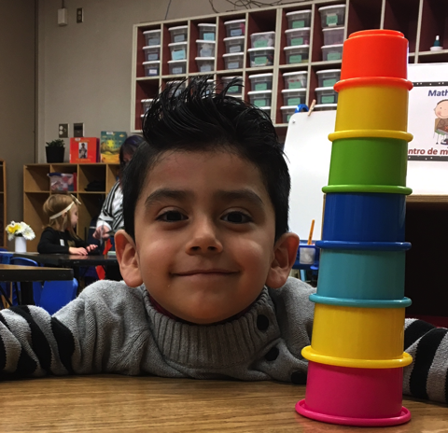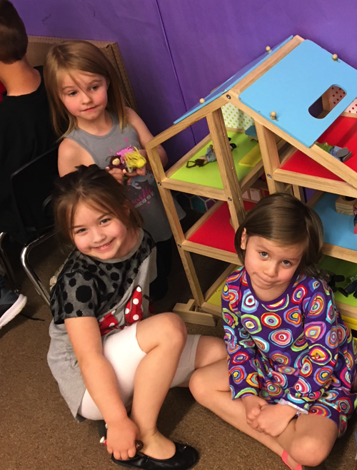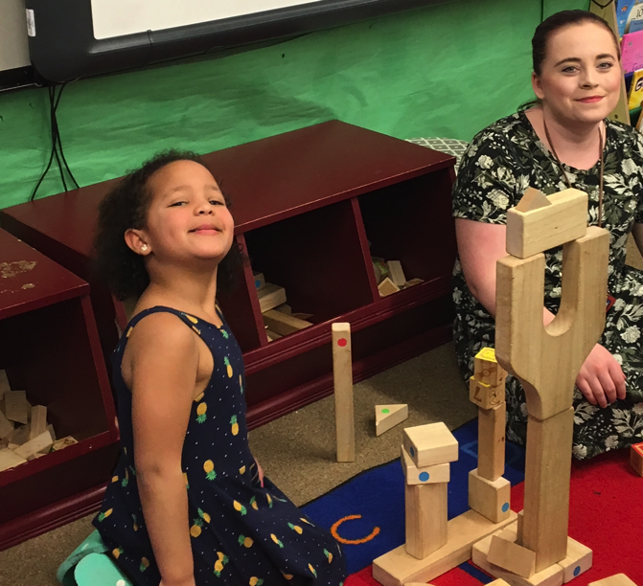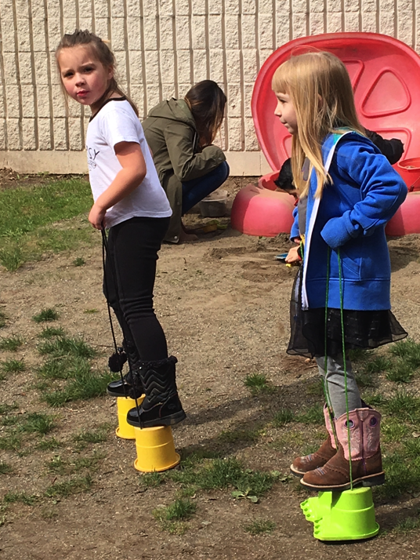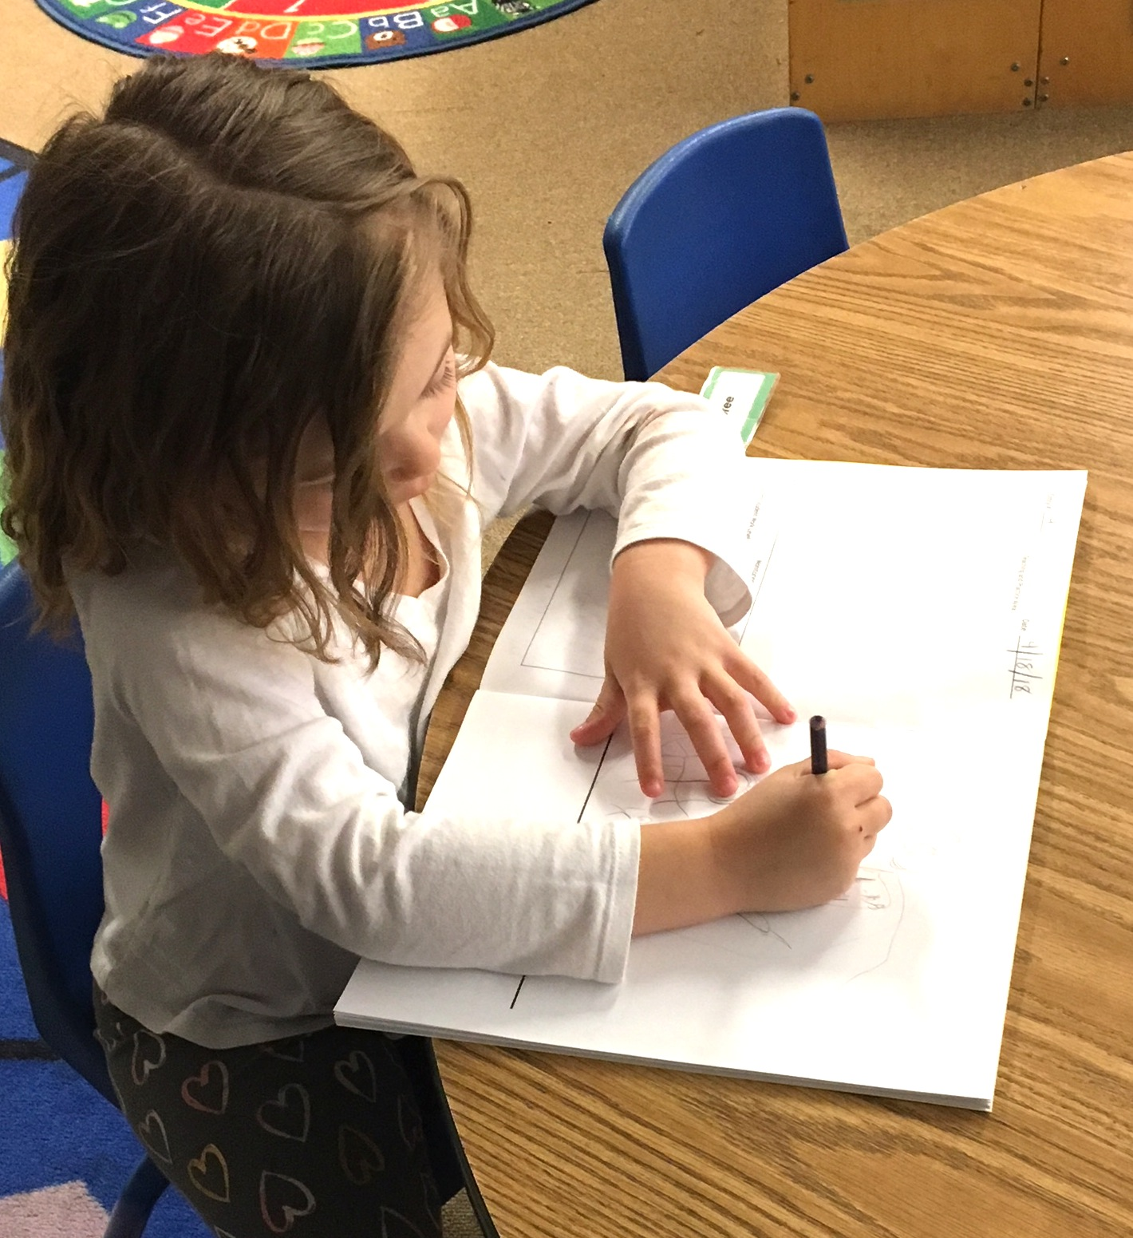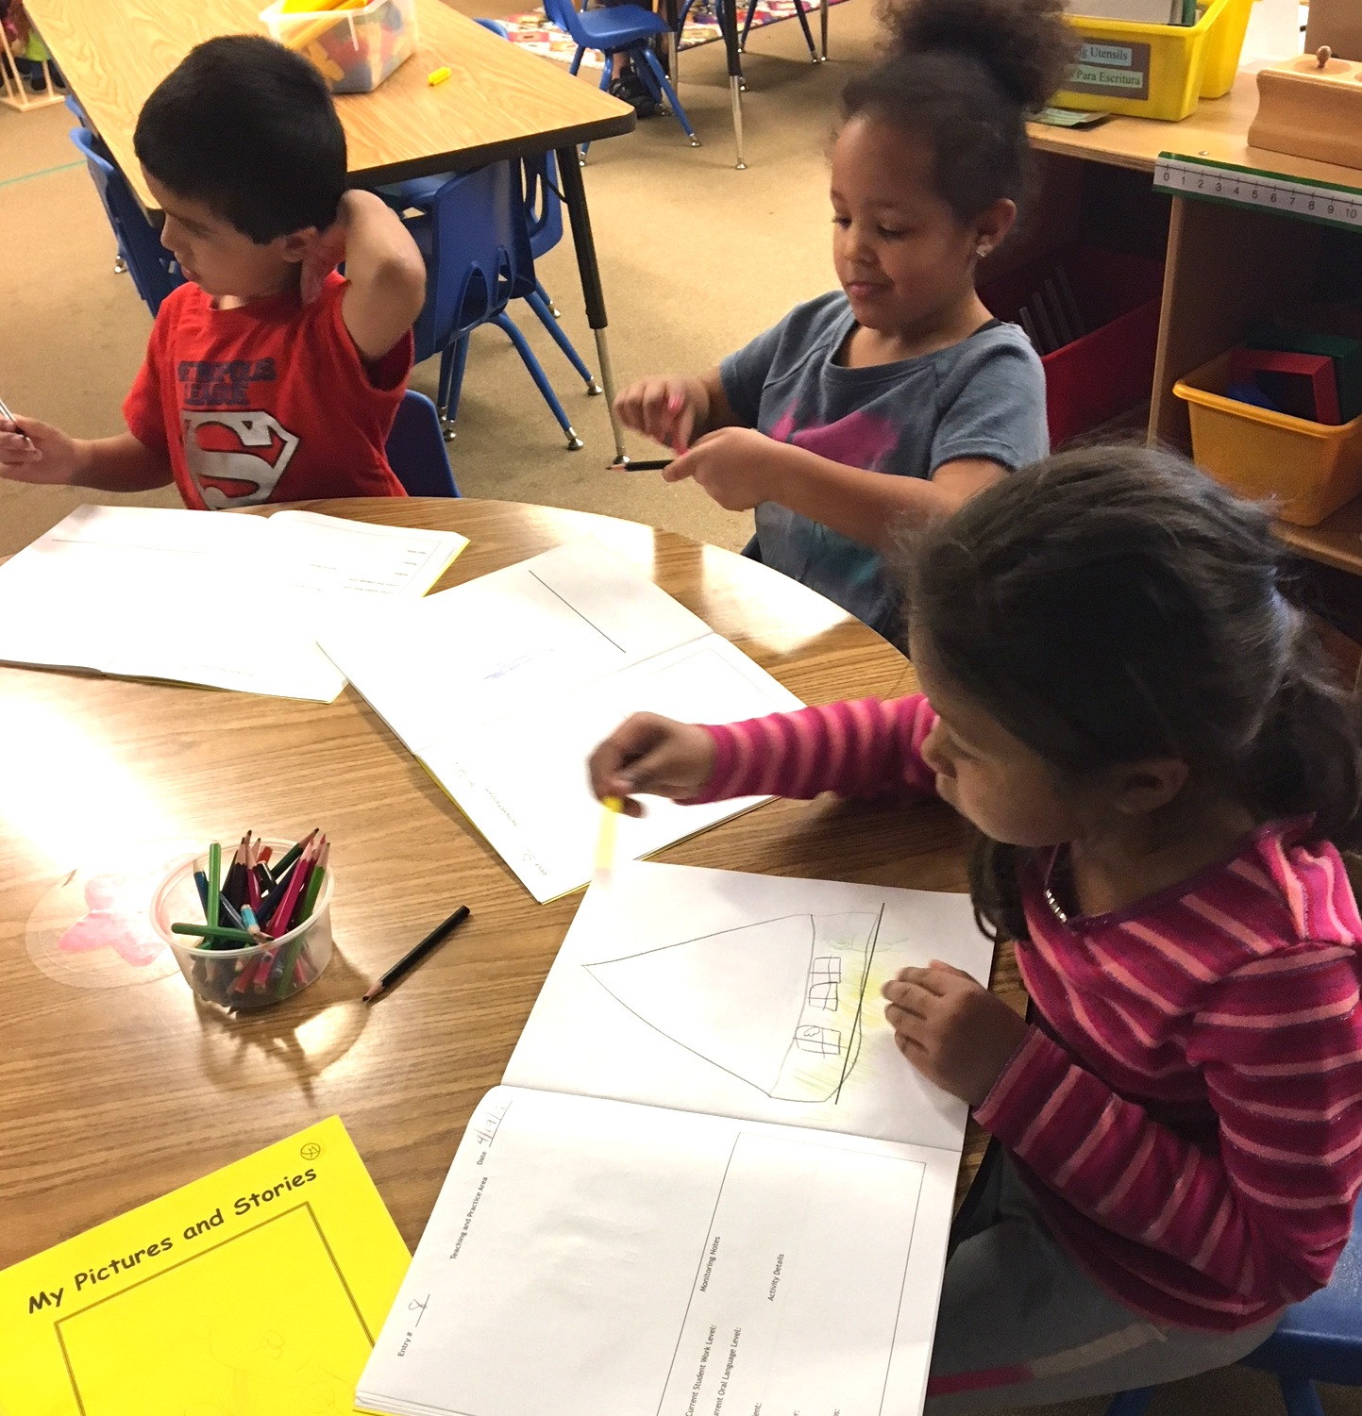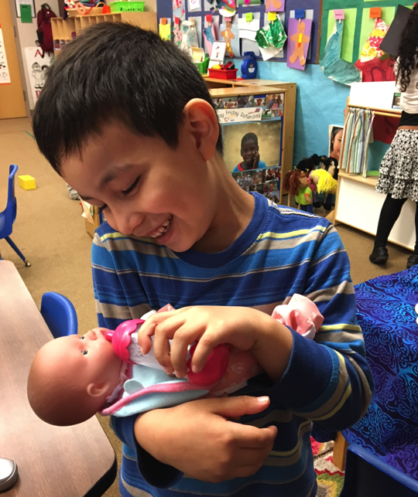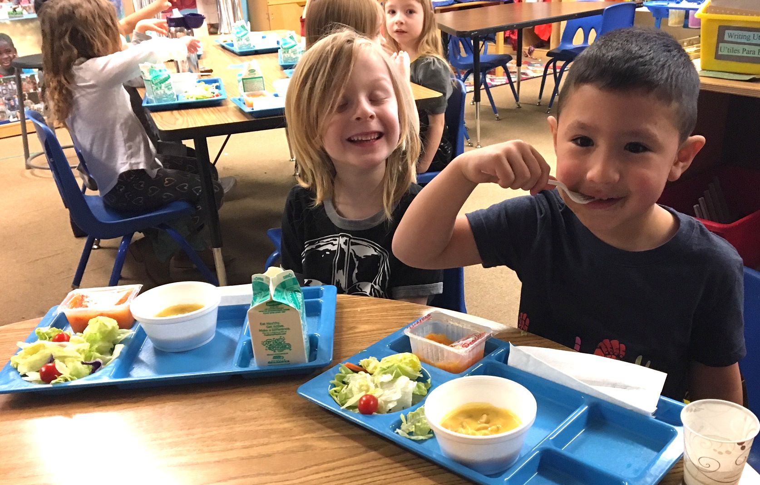 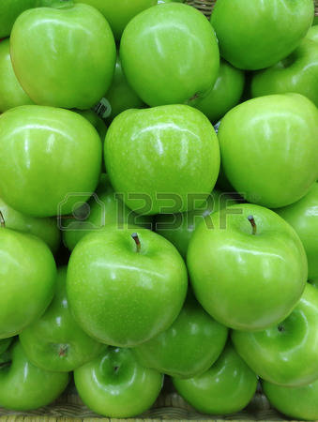

Other things we are learning in class: playing cooperative games with 3-4 people, number recognition and writing, reading “Bob Books“ and welcoming another student in Green class.

Our end of the year class Celebration for Blue and Green will be on May 31st. We are making decorations and preparing songs for this day. Please mark you calendars and save this date so you can be part of your child’s special day. More information will come out with specific times at a later date.