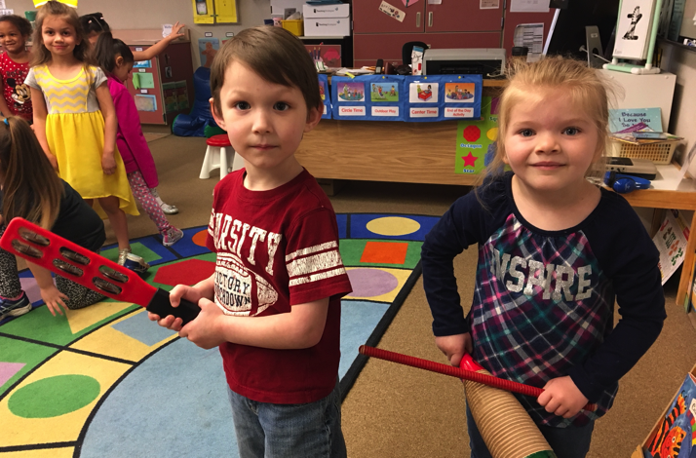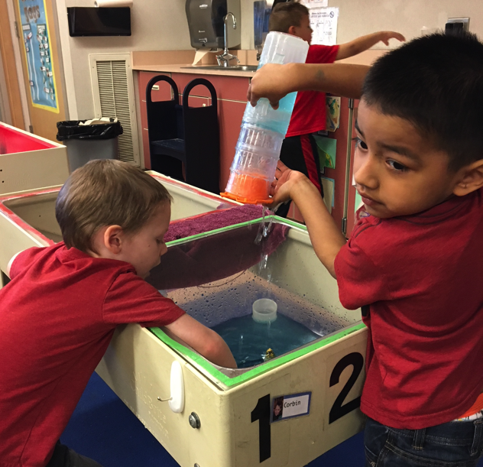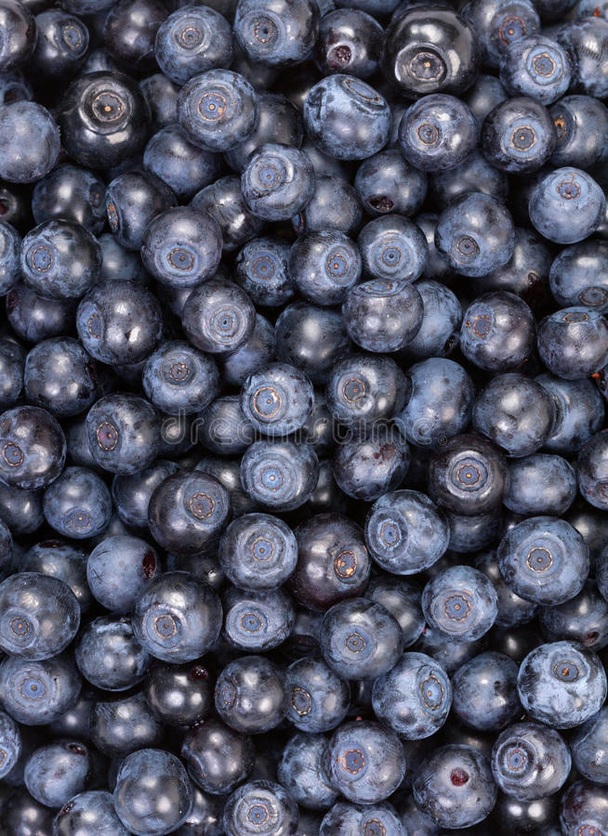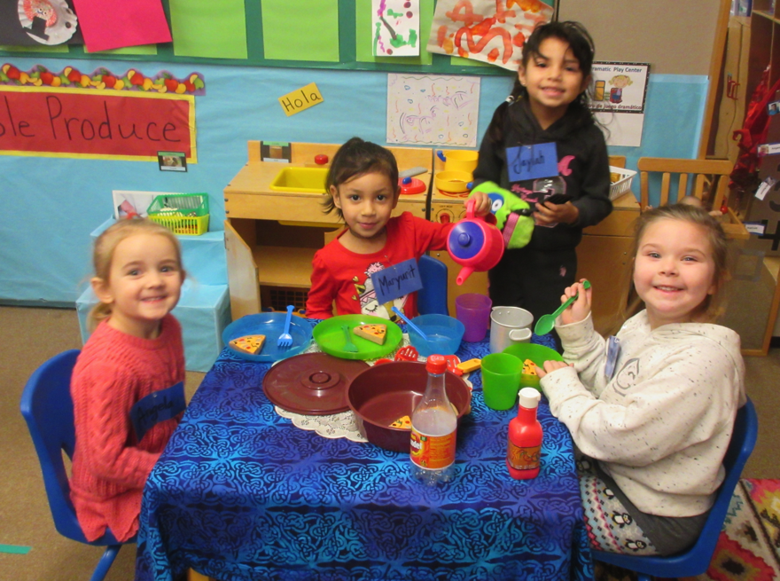 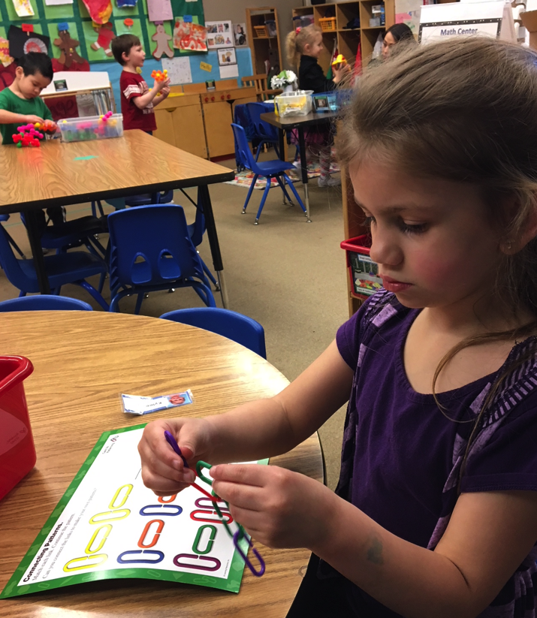

Can you believe that the end of Pre-school is near? We have lots of things coming up and we hope you can join us. Be checking your child’s backpack and sign-in area for important information.

We have been enjoying time outside with the weather brightening up. Children are having fun hunting and spying for insects, they use tweezers and collect grass and twigs for their home and place them in the bug boxes. In class we read the story the Hungry Caterpillar learning how it changes into a butterfly, we also read Grouchy Ladybug we discovered the ladybug was “GROUCHY” because she was hungry. What do ladybugs eat? Aphids! So, we made “aphids on a log snack” and ate it in class. The ingredients are: celery and cream cheese topped with golden raisins. Let your child make you this snack at home. You may like it! cont..